**SCHOOL MANAGEMENT SYSTEM**

create database school_managment_system;

use school_managment_system;

create table Students(

student_id varchar (11) primary key not null,

first_name varchar(30) default null,

last_name varchar(30) default null,

official_email varchar(30) default null,

personal_email varchar(30) default null,

roll_number int (11) default null,

date_of_birth date default null,

phone_number int (20) default null,

parent_firstname varchar(30) default null,

parent_lastname varchar(30) default null,

parent_phone_no int(20) default null,

date_of_joining date default null,

parent_occupation varchar(30) default null,

gender varchar (30) default null,

cnin varchar(30) default null,

age int(11) default null

);

create table School_staff(

staff_id varchar (11) primary key not null,

first_name varchar(30) default null,

last_name varchar(30) default null,

date_of_birth date default null,

age int(11) default null,

official_email varchar(30) default null,

personal_email varchar(30) default null,

phone_number int (20) default null,

date_of_joining date default null,

gender varchar (30) default null,

cnin varchar(30) default null,

qualification varchar(30) default null,

previous_employment varchar(30) default null,

salary int (20) default null,

bonus int (20) default null

);

create table course(

course_id varchar (11)not null,

course_name varchar(11) not null,

primary key(course_id,course_name),

description varchar(30) default null

);

create table Fee(

fee_id varchar (11) primary key not null,

student_id varchar (11) not null,

fine int (11) default null,

tax int(11) default null,

monthly_fee int (20) default null,

disscount int (11) default null,

extra_charges int (20) default null,

sibling_disscount int (20) default null

);

create table Student_Timetable(

timetable_id varchar (11) primary key not null,

student_id varchar (11) not null,

course_id varchar (11) not null,

venue int (20) default null,

rome_no int (11) default null,

time time default null

);

create table teacher_Timetable(

timetable_id varchar (11) primary key not null,

teacher_id varchar (11) not null,

course_id varchar (11) not null,

venue int (20) default null,

rome_no int (11) default null,

time time default null

);

create table students_grades(

grade_id varchar(11) primary key not null,

student_id varchar (11) not null,

Assignment_score int (11) default null,

quizzez_score int (11) default null,

midterm_score int (11) default null,

finalterm_score int (11) default null,

grade varchar (11) default null

);

create table student_class(

student_class_id varchar (11) primary key not null,

student_id varchar (11) not null,

new_roll_no int(11) default null

);

create table Address(

id varchar (11) primary key not null,

house_no int (11) default null,

street_no int (11) default null,

city varchar (20) default null

);

create table Address_student(

Aid varchar(11) not null,

Sid varchar (11) not null,

primary key(Aid,Sid)

);

create table Address_staff(

Aid varchar(11) not null,

STid varchar (11) not null,

primary key(Aid,STid)

);

alter table Address_student add constraint foreign key (Aid) references Address(id);

alter table Address_student add constraint foreign key (Sid) references Students(student_id);

alter table Address_staff add constraint foreign key (Aid) references Address(id);

alter table Address_staff add constraint foreign key (STid) references School_staff(staff_id);

alter table Fee add constraint foreign key (student_id) references Students(student_id);

alter table Student_Timetable add constraint foreign key (student_id) references Students(student_id);

alter table Student_Timetable add constraint foreign key (course_id) references course(course_id);

alter table teacher_Timetable add constraint foreign key (course_id) references course(course_id);

alter table students_grades add constraint foreign key (student_id) references Students(student_id);

alter table student_class add constraint foreign key (student_id) references Students(student_id);

insert into Students values('S1','ayesha','malik','ayesha.malik@ucp.edu.pk','ayesha@yahoo.com',123,'20-3-2000',98765431,'malik','hassan',090078601,'12-9-2005','business','F','35202-7654-1',20);

insert into Students values('S2','sadia','shahbaz','sadia.shahbaz@ucp.edu.pk','sadia@yahoo.com',124,'12-7-2000',1234567,'hassan','malik',090078602,'9-8-2004','business','F','35202-6543-1',20);

select * from students;

desc students;

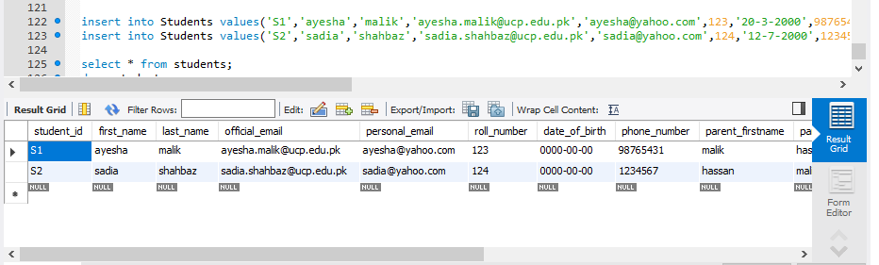

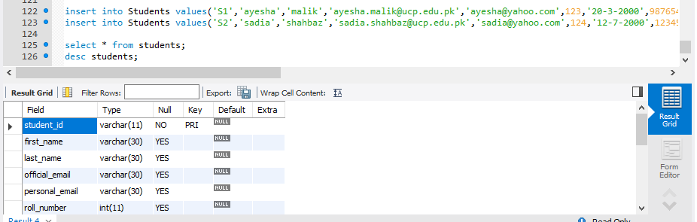

insert into School_staff values('ST1','maria','malik','12-6-1999',22,'maria@ucp.edu.pk','maria@outlook.com',1234567,'12-3-2008','F','35202-8765-0','masters','punjab school',20000,350);

insert into School_staff values('ST2','noor','fatima','23-6-1998',20,'noor@ucp.edu.pk','noor@outlook.com',9876543,'2-3-2009','F','35202-1234-1','masters','punjab school',10000,200);

select * from School_staff;

desc School_staff;

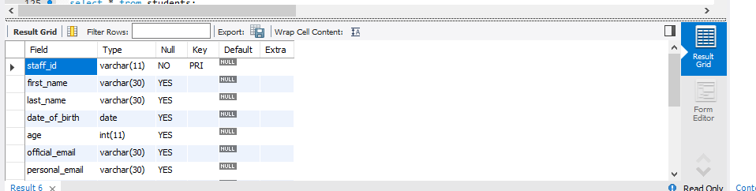 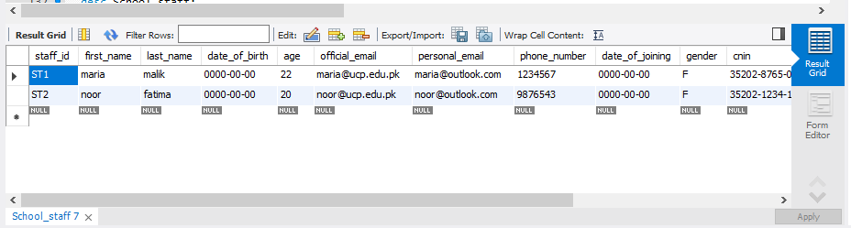

insert into course values('C1','ooad','it is for programming');

insert into course values('C2','db','it is for programming');

select * from course;

desc cours

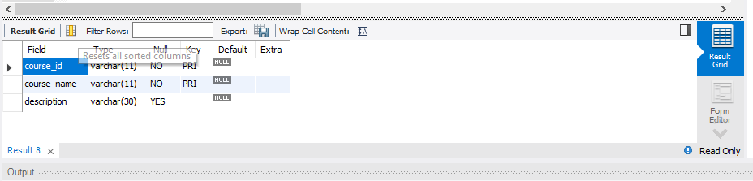 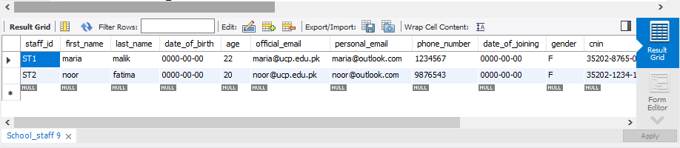

insert into fee values('F1','S1',3000,34000,50000,10000,2000,0);

insert into fee values('F2','S2',3000,34000,50000,10000,2000,0);

select * from fee;

desc fee;

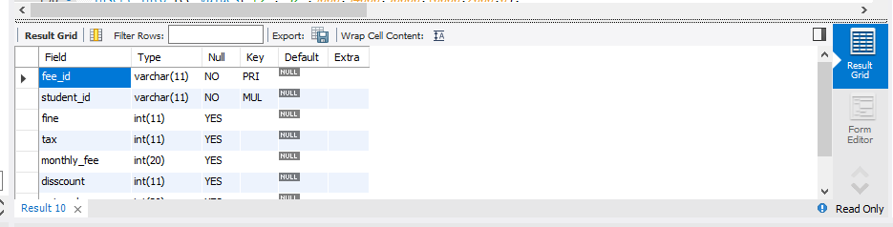

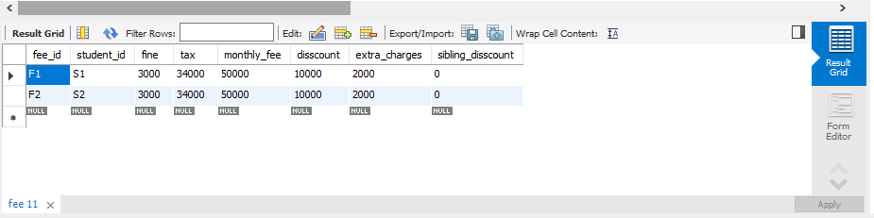

insert into Student_Timetable values('Ti1','S1','C1',12,23,12.50);

insert into Student_Timetable values('Ti2','S2','C2',12,23,12.50);

select * from Student_Timetable;

desc Student_Timetable;

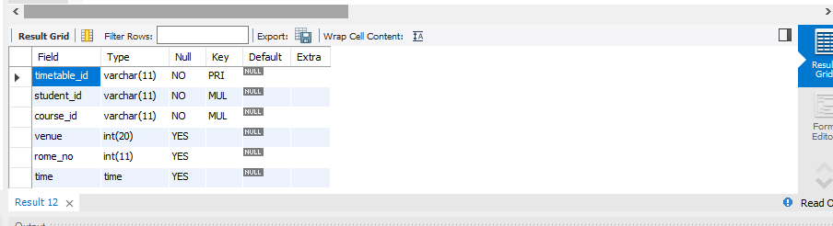

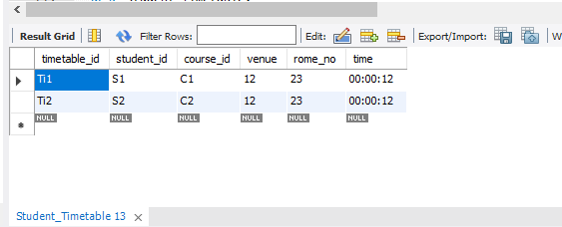

insert into teacher_Timetable values('Te1','ST1','C1',12,23,12.50);

insert into teacher_Timetable values('Te2','ST2','C2',12,23,12.50);

select * from Student_Timetable;

desc Student_Timetable;

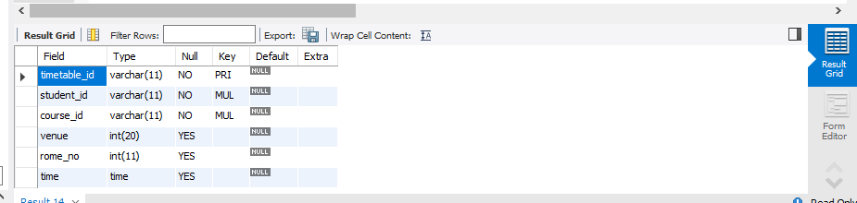

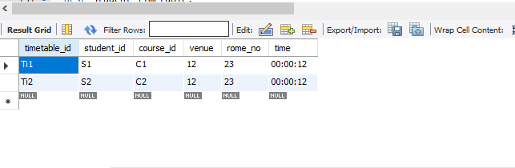

insert into students_grades values('G1','S1',40,50,60,79,'A');

insert into students_grades values('G2','S2',40,50,60,90,'A+');

select * from students_grades;

desc students_grades;

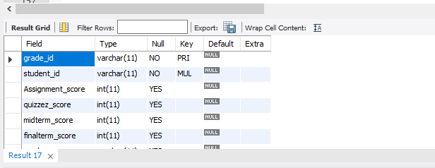

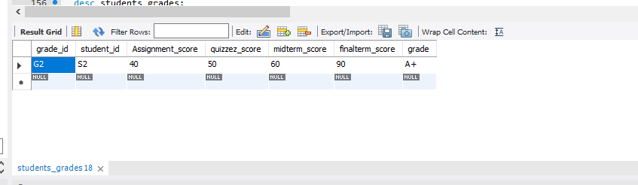

insert into student_class values('SC1','S1',345);

insert into student_class values('SC2','S2',789);

select * from student_class;

desc student_class;

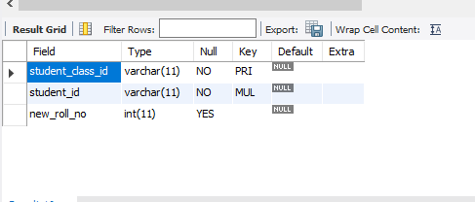

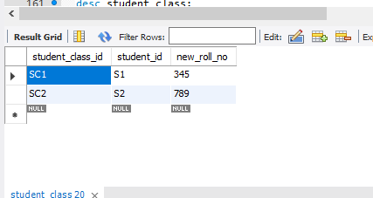

insert into Address values('T1',234,12,'lahore');

insert into Address values('P1',234,12,'lahore');

select * from Address;

desc Address;

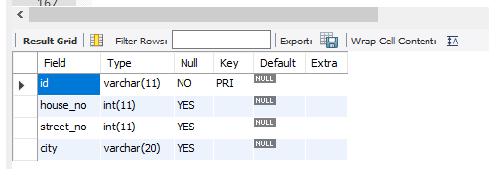

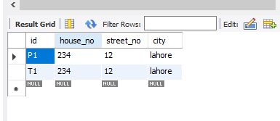

insert into Address_student values('T1','S1');

insert into Address_student values('P1','S2');

select * from Address_student;

desc Address_student;

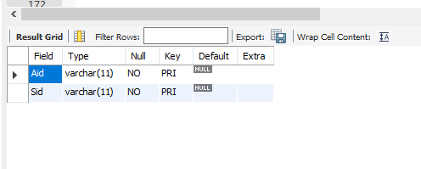

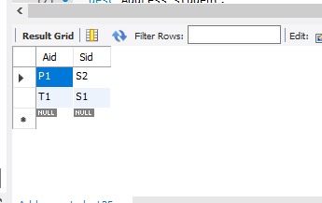

insert into Address_staff values('T1','ST1');

insert into Address_staff values('P1','ST2');

select * from Address_staff;

desc Address_staff;

